Calculus I
Visual Examples
Continuity at a Point

Determine if the following functions are continuous. If the function has discontinuities determine where it is discontinuous and the type of discontinuity. If the discontinuity is removable, write a new equation that is continuous.

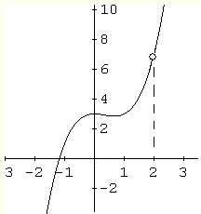
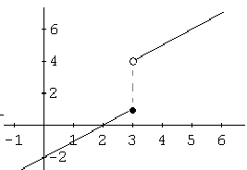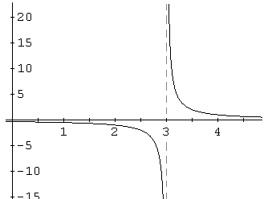

Continuity at a Point

A function is continuous at a point if . This means that there are three conditions that must be met for a function to be continuous at a point.

1.
2.
3.

Note:
A polynomial function is continuous at every point on its domain.
A rational function is continuous at every point in the domain except where the denominator equals zero.

Determine the domain of each function and if the function is continuous. If the function has discontinuities determine where it is discontinuous and the type of discontinuity.
1) 2) 3)

4) 5)

Determine if the following functions are continuous. If the function has discontinuities determine where it is discontinuous and the type of discontinuity. If the discontinuity is removable, write a new equation that is continuous.

6) 7) 8)

More Piecewise Functions – are they continuous?
9) 10)

Find the value of “a” for which the function is continuous.
11) $f\left(x\right)=\left\{\begin{matrix}2x+a & \text{if} & x<4 \\ x^{2}−a & \text{if} & x≥4\end{matrix}\right.$ 12) $f\left(x\right)=\left\{\begin{matrix}\text{ax}+1 & \text{if} & x≤3 \\ {\text{ax}}^{2}−1 & \text{if} & x>3\end{matrix}\right.$

